Please refer below YouTube link for step-by-step MongoDB installation.

<https://youtu.be/OiMOQr457Qs>

Install MongoDb atlas:

Step 1:

Go to official site <https://www.mongodb.com/atlas> and click on Try Free as shown below.

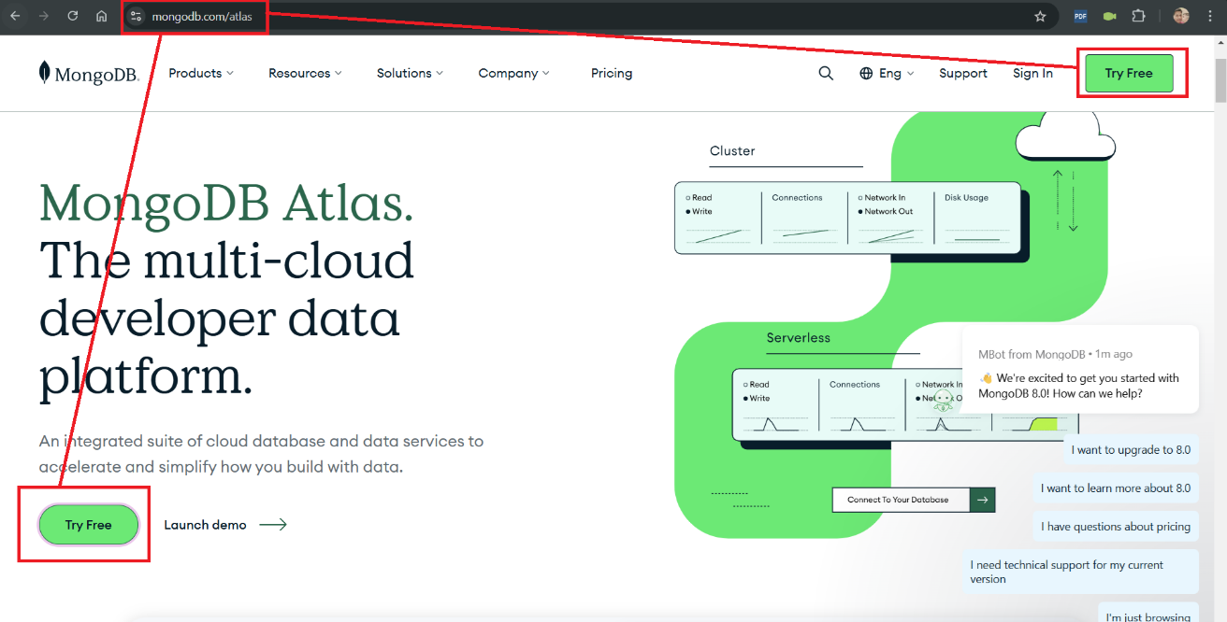

Once you click on Try free it will redirect to signup page as shown below to download atlas.

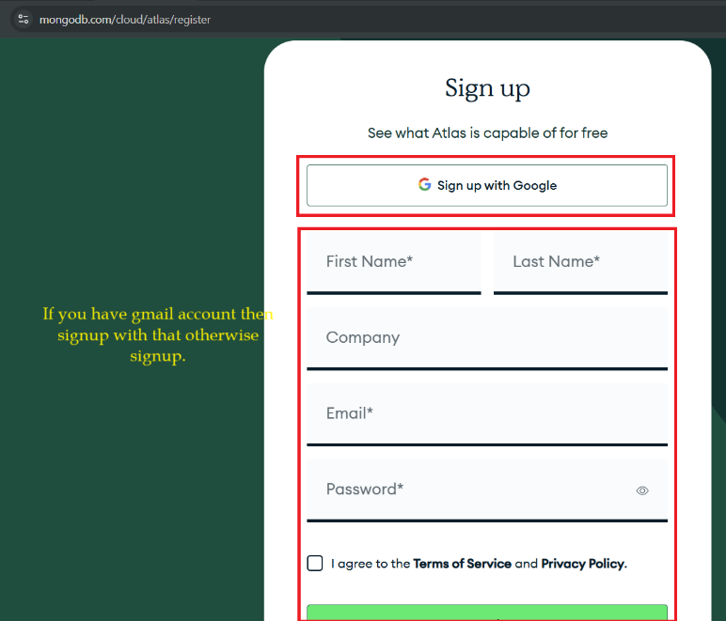

After sign in or signup you will redirect to mongoDb organization page where you need to create at least one to work with MongoDb database as shown below screenshot.

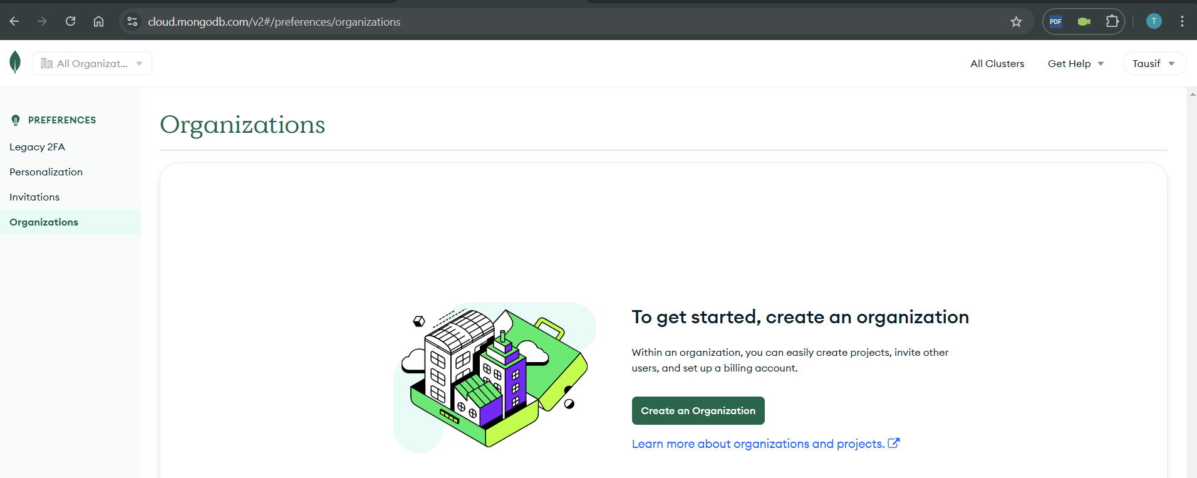

Step 2:

Here we will create one organization with name ‘NodeTutorialWithMongoDb’

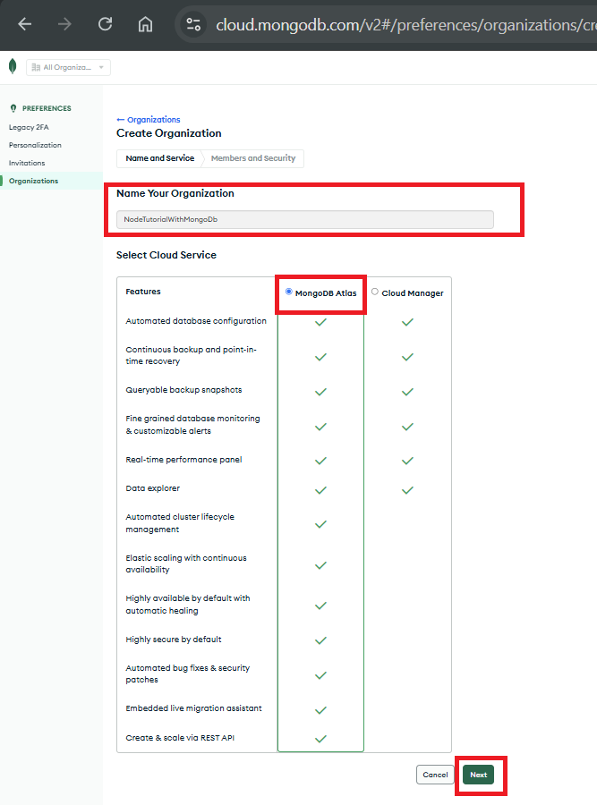

After click on Next button next page will appear where you can add members and security optional email id.

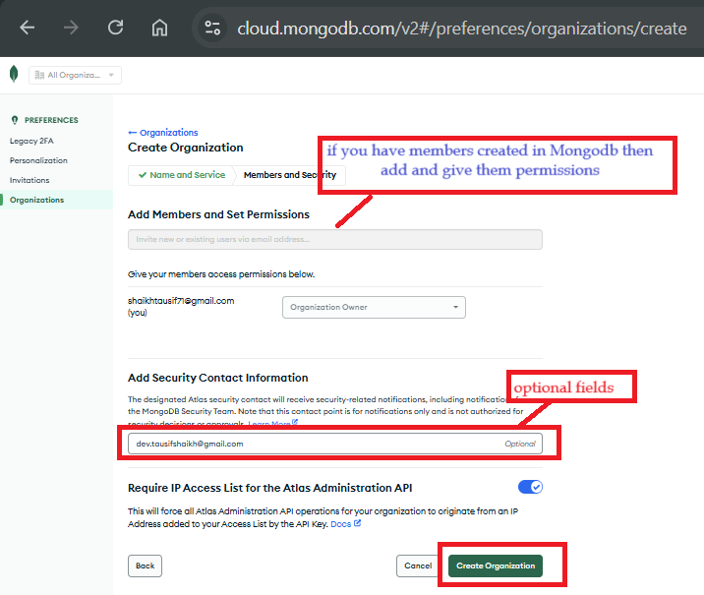

Create Project in Organization:

Once above organization created, we will see blank organization page where we can create multiple projects. Each project may have once or more clusters and each cluster may have once or more collections(databases).

Step 1: Click on New project button as shown in below screenshot to create new project in organization.

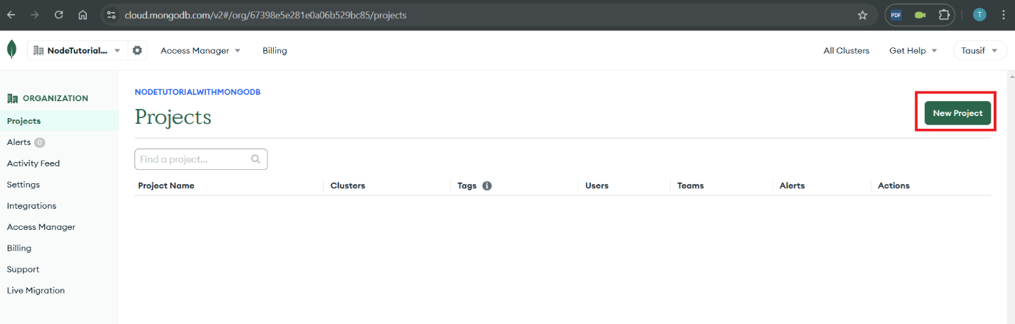

Step 2: enter name of project project in my case I put project name ‘PortfolioDB’, you my enter your desire name and click on Next button.

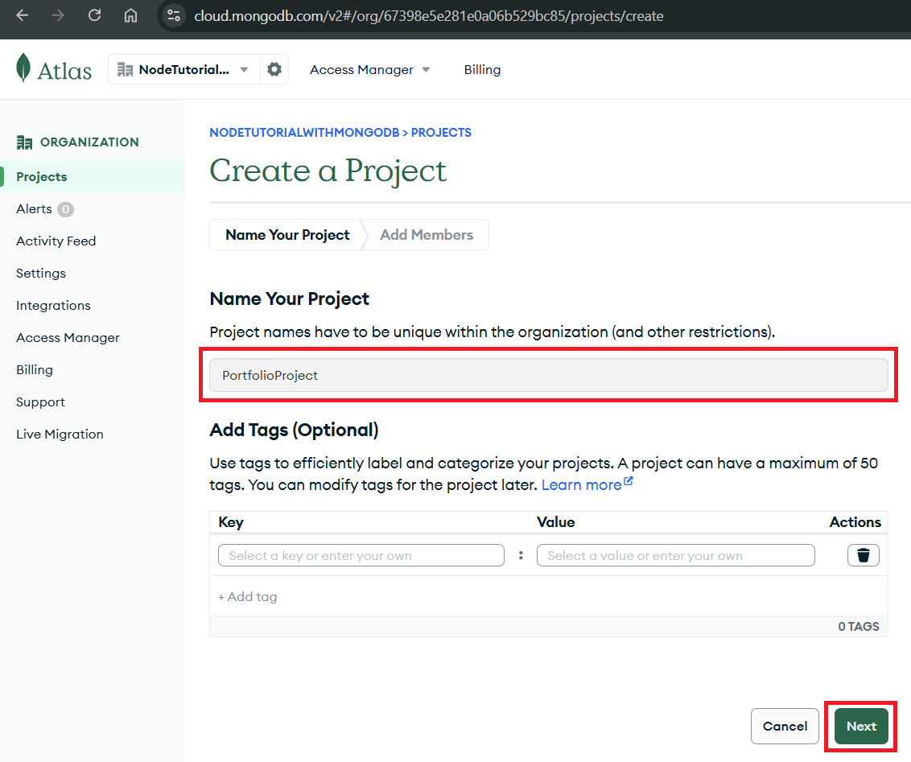

Step 3: in below screen you can add member and set permissions and click on create project button.

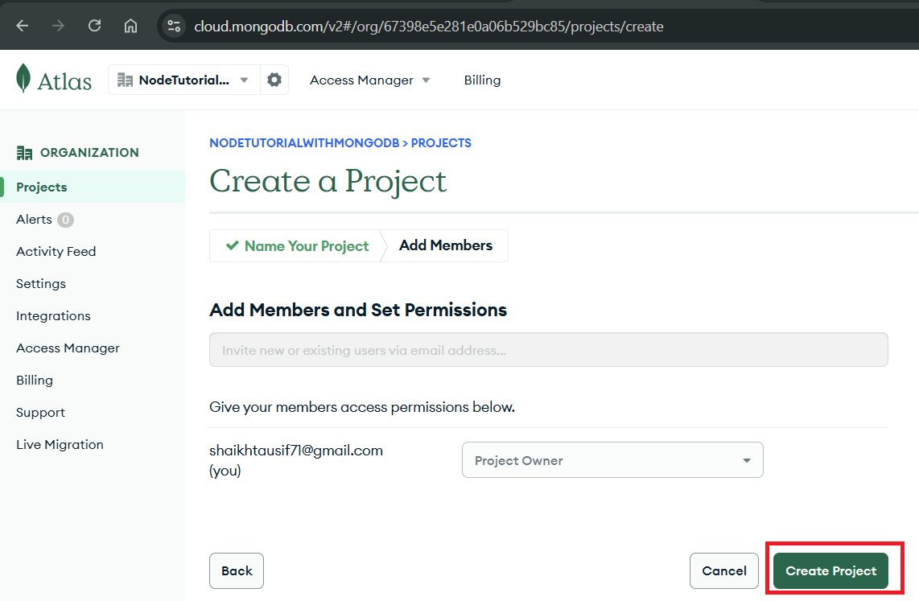

Step 4: once project created you will see your project inside your organization, now create cluster where you can create collections (database) and documents (rows).

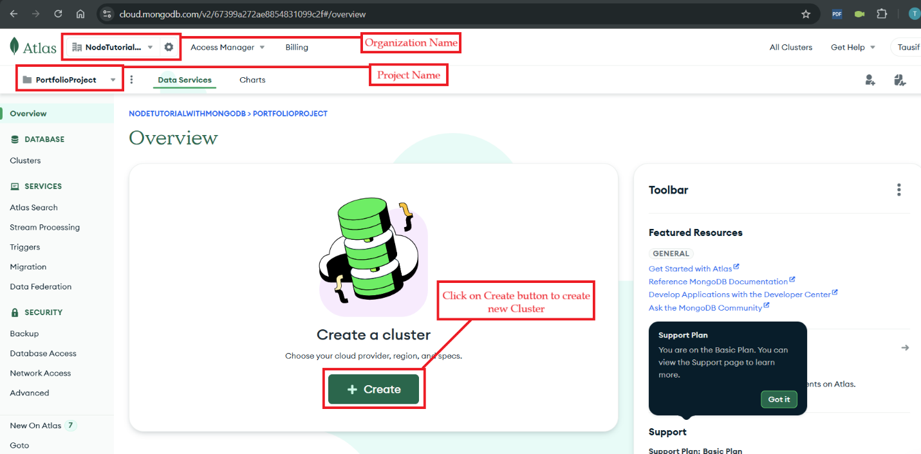

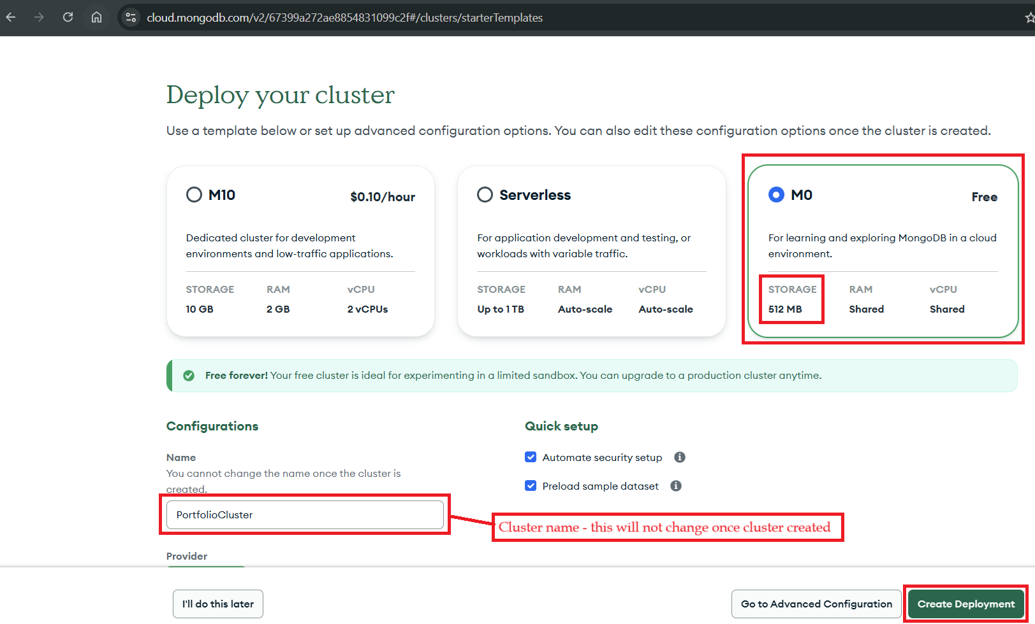

Once we click on deployment, one popup is display where you will see username & password from which we can connect our database using connection string.

